Control Setup: Web Controller → CoppeliaSim
This section explains how to connect the browser-based controller with the CoppeliaSim RoboSoccer scene and start manual control.

Step 1: Download the Controller Files
Click the provided link in this document:
Download the Remote Controller ZIP file
(The Google Drive link will be attached here)
Extract the ZIP file to any folder on your system.

Step 2: Open the Controller Project
- Open the extracted folder in any IDE
- Recommended: Visual Studio Code (VS Code)
  - Download VS Code
  - Installation Guide
After opening the folder, your workspace will look similar to this:
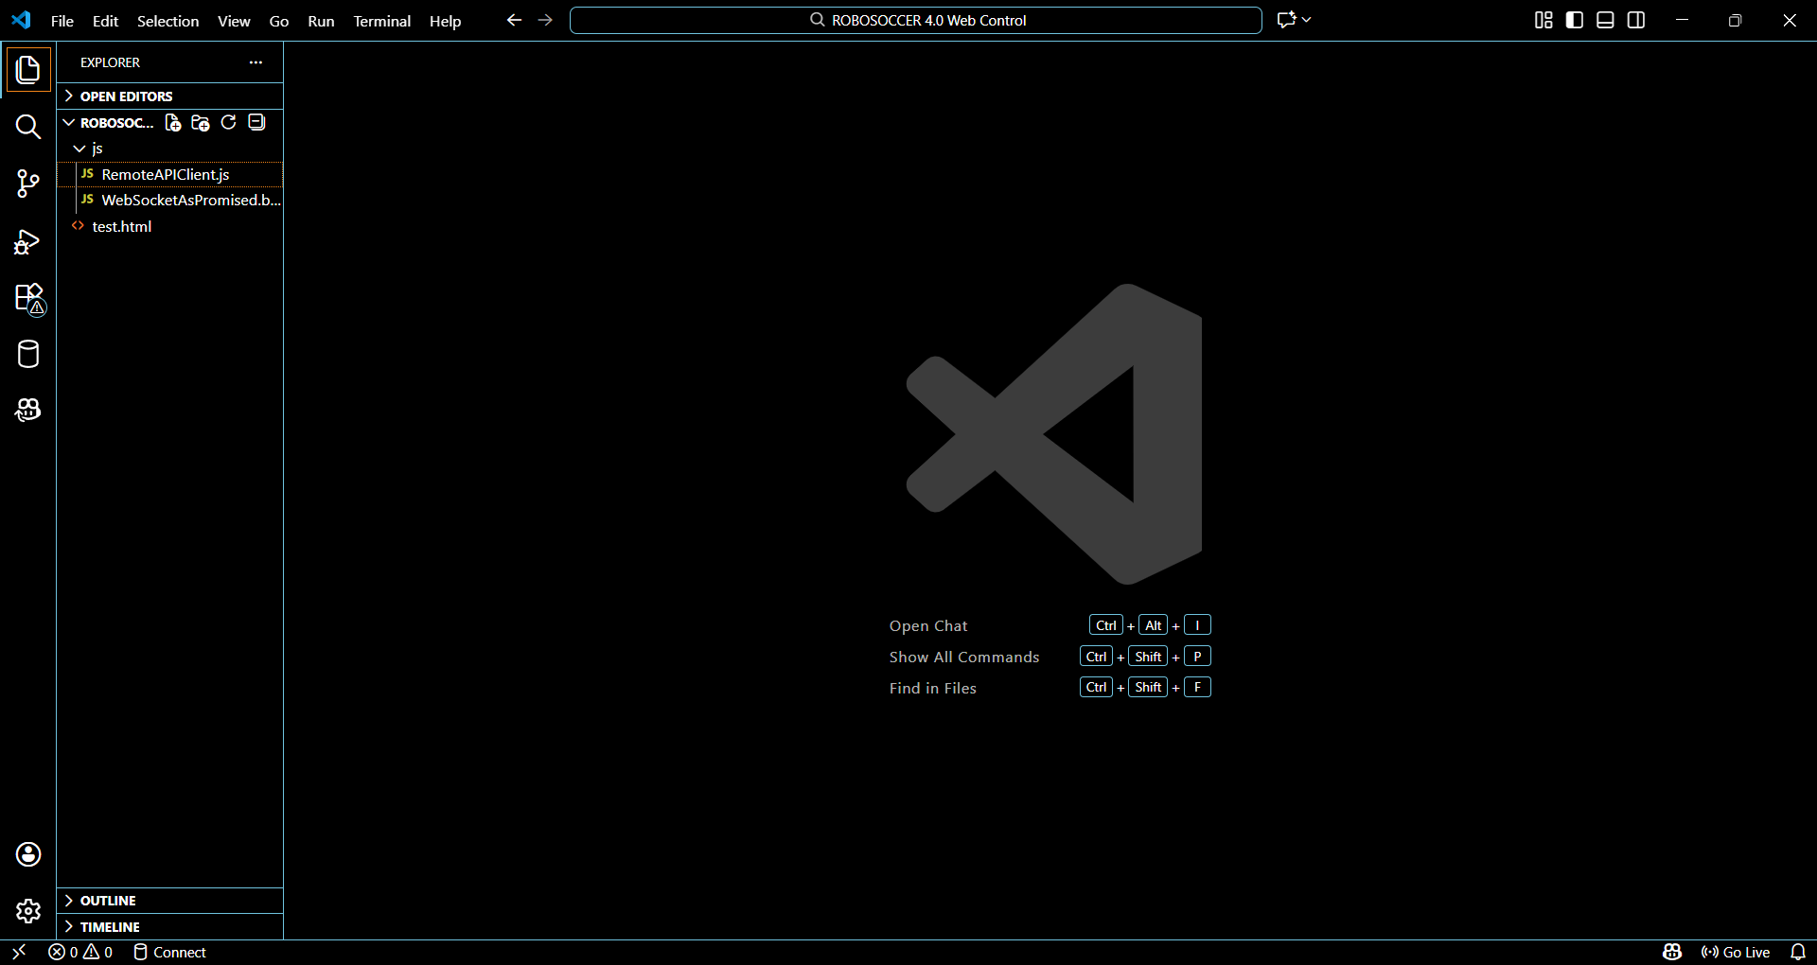

Step 3: Install Live Server (Required)
Inside VS Code:
- Go to Extensions
- Search for Live Server (by Ritwick Dey)
- Install the extension
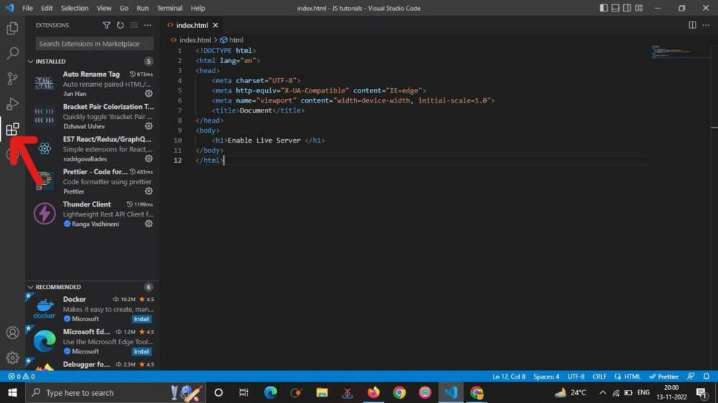

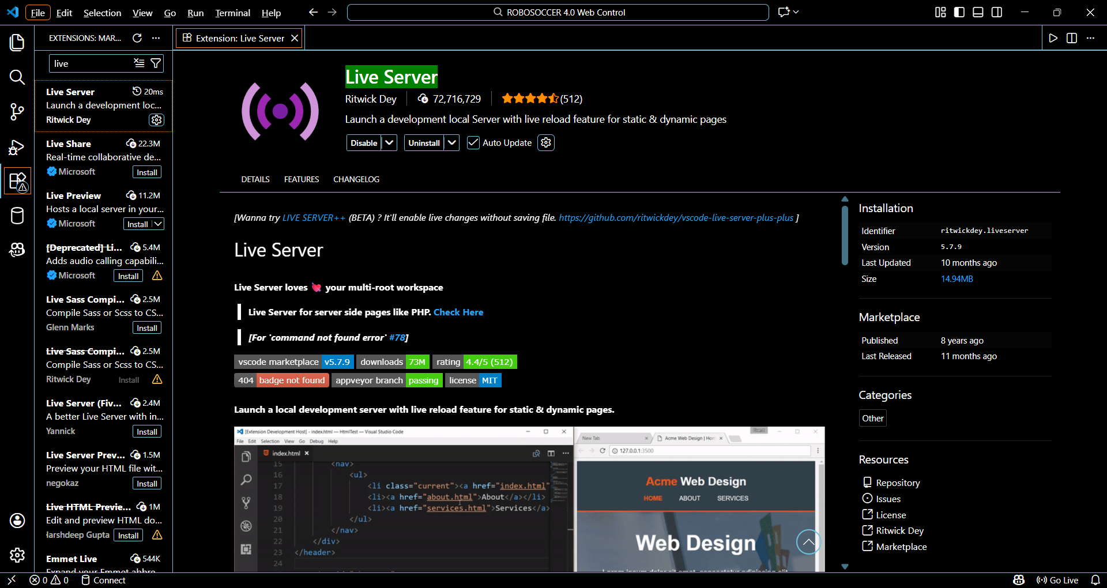

Step 4: Launch the Controller Web App
- Open the file test.html
- Click “Go Live” at the bottom-right of VS Code
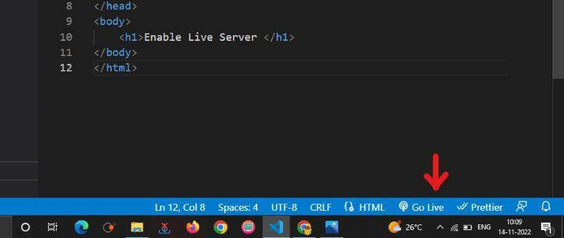
Your browser will automatically open a local site, typically:
http://127.0.0.1:5500/test.html
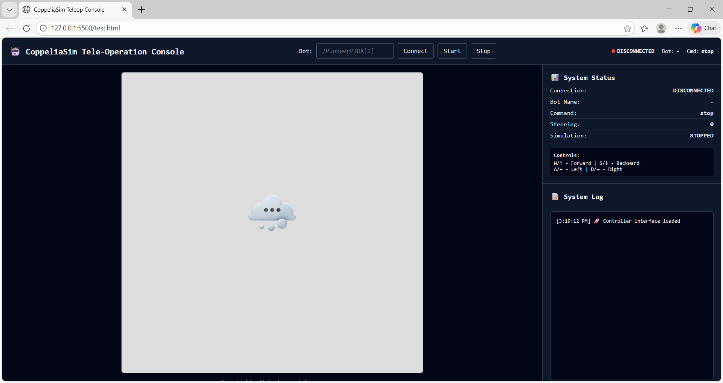

Step 5: Open the RoboSoccer Scene in CoppeliaSim
- Launch CoppeliaSim
- Open the provided RoboSoccer scene file (.ttt)
The scene will load with:
- Soccer arena
- Robot
- Ball
- Obstacles
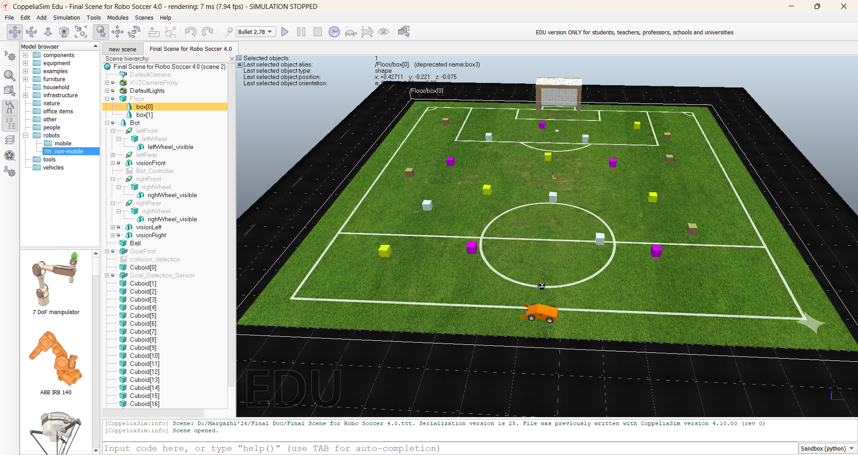

Step 6: Connect the Controller to the Robot
In the web controller page:
- In the Bot input field, type:
- /Bot
- Click Connect
- Once connected, click Start
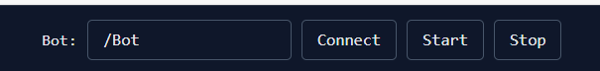
Connection status will update on the right-side System Status panel.

Step 7: Write Your Control Logic
Inside CoppeliaSim:
- Open the robot’s child script
- Script name: Bot controller
- Write your motion logic here (wheel velocity, ramping, control discipline)
⚠️ Do not modify:
- Robot model
- Scene objects
- Physics settings
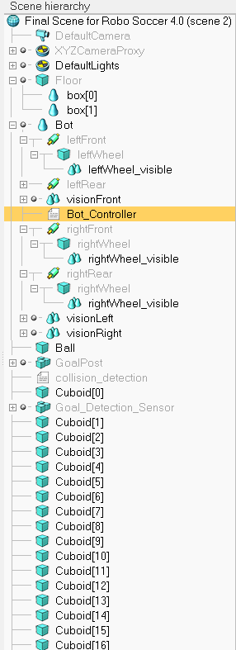

Step 8: Control the Robot (Keyboard)
Once connected and started:
Keyboard Controls
- W → Forward
- S → Backward
- A → Left
- D → Right
The robot will now respond in real time inside CoppeliaSim.

IMPORTANT NOTES
- The controller runs locally on your system
- Internet is not required after setup
- Autonomous behavior is strictly prohibited
- All motion must obey the defined control constraints
- The cursor must be active on the controller website window.
Click anywhere inside the web controller page before using the keyboard. If the cursor is not focused on the website, key presses (W, A, S, D) will not be detected, and the robot will not move. This is expected behavior for browser-based control.

